Goal Setting & The Glory of God

Reagan Rose

# Founder of Redeeming Productivity

1. **Objectives for This Workshop**
   1. Establish a biblical mindset for setting goals
   2. Teach you a process to set effective & God-glorifying goals
2. **What Is a Goal?**
   1. A goal is a specific outcome or state of being you desire to reach within a defined period.
   2. Goals are aspirational not strategic
   3. Goals provide direction and purpose for our efforts
   4. Goals serve as a clear benchmark of progress and success.
3. **How Good Goals Glorify God**
   1. The goal of goals is the glory of God
   2. Goals are a vehicle to reach greater faithfulness
4. **Planning Isn’t a Sin, It’s Wisdom**
   1. James merely condemns arrogant goal-setting which is not submitted to God (James 4:13–16).
   2. The Scriptures praise goal setting and planning as wisdom (Proverbs 6:6–8; 21:5; 24:27).
   3. The Apostle Paul’s Example of Humble Planning
      1. Had a clear aim (Rom 15:20)
      2. Had faith-filled flexibility[1]
      3. Had a diligent work ethic (1 Cor 15:10)
5. **How to Set God-Glorifying Goals**
   1. Evaluate your domains of stewardship.
      1. Grade yourself 1–5 on how faithful a steward you are being in each of the major 6 areas of life.
         1. Spiritual
         2. Relational
         3. Vocational
         4. Physical
         5. Financial
         6. Recreational
      2. Usually, the best place to set a big goal is in one of the areas you scored the lowest.
   2. Write your specific goal.
      1. People who write their goals down are 91% more likely to reach them.[2]
      2. Make the goals specific with S.M.A.R.T. methodology
         1. Specific – Make it clear
         2. Measureable – Make it quantifiable
         3. Achievable – Make it realistic
         4. Relevant – Make it matter
         5. Time-Bound – Make it stop
      3. Use the goal-setting worksheet (at end of these notes)
   3. Interrogate your motives & further define your goal
      1. Why did I choose this goal and not another?
      2. How does this goal contribute to my calling and God’s glory? (Colossians 3:17)
      3. Seek outside counsel (Proverbs 15:22)
      4. Pray for wisdom & commit your plans to the Lord (Proverbs 3:5–6; 16:3; James 1:5–7)
   4. Break your goal down
      1. If it’s a long-term goal, create shorter projects or waypoints.
      2. Define at least one habit that will help you reach the goal.
      3. Develop routines for daily working on your goal
      4. Consult the worksheet to be reminded of why you’re doing this.
6. **Consider Enlisting Accountability**
   1. Set goals with your staff, a fellow pastor, spouse, or friends
   2. Or join the Redeeming Productivity Academy and grow with other productivity-minded believers.

**Note**: to download these notes, additional resources, slides, and any templates mentioned in this talk, go to <https://redeemingproductivity.com/equip>

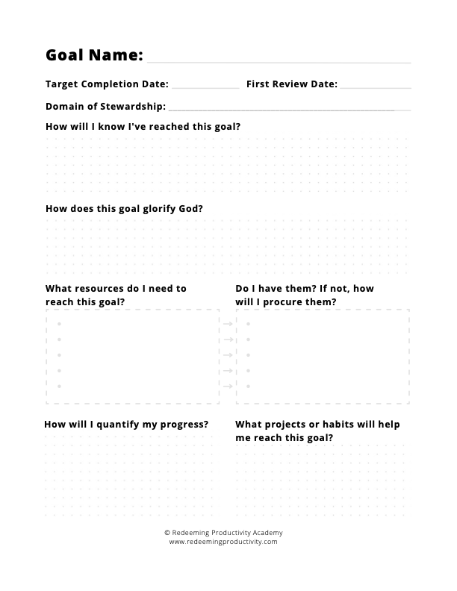

1. Paul’s plan to visit the Thessalonians was hindered by Satan (1 Thess 2:18). He had his thorn in the flesh (2 Cor 12:7–10). His plans to go to Spain probably never materialized (1 Tim 3:14). But those setbacks didn’t seem to phase him. Because though he had his plans, he always subjected them to the plans of the Father. When he was stopped from preaching in Asia, he went to Phyrigia and Galatia. When he couldn’t go to Bithynia, he saw a vision from God of a man calling him to Macedonia. So he went there instead (Acts 16:6–10).
2. “What route are you taking to the polling station? At what time are you planning to go? What bus will get you there?” (David W. Nickerson and Todd Rogers, “Do You Have a Voting Plan? Implementation Intentions, Voter Turnout, and Organic Plan Making,” Psychological Science 21, no. 2 (2010): 194–199.)